LAB WORK 3

1. INSERT INTO airport (airport_id, airport_name, country, state, city, created_at, updated_at)
SELECT COALESCE((SELECT MAX(airport_id) FROM airport), 0) + gs AS airport_id,
'Airport_' || gs AS airport_name,
'Country_' || (gs % 5) AS country,
'State_' || (gs % 10) AS state,
'City_' || (gs % 20) AS city,
NOW() AS created_at,
NOW() AS updated_at
FROM generate_series(1, 200) AS gs;
SELECT * FROM airport;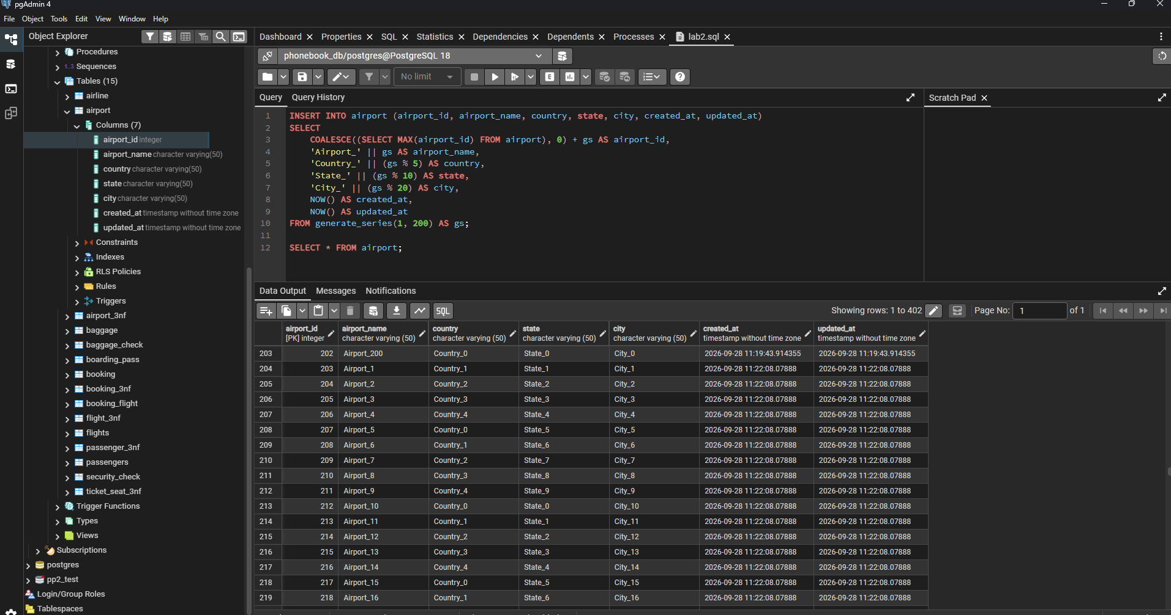

2. INSERT INTO airline (airline_id, airline_code, airline_name, airline_country, created_at, updated_at)
VALUES (COALESCE((SELECT MAX(airline_id) FROM airline), 0) + 1,
'KZ',
'KazAir',
'Kazakhstan',
NOW(),
NOW()
);

SELECT * FROM airline where airline_country='Kazakhstan';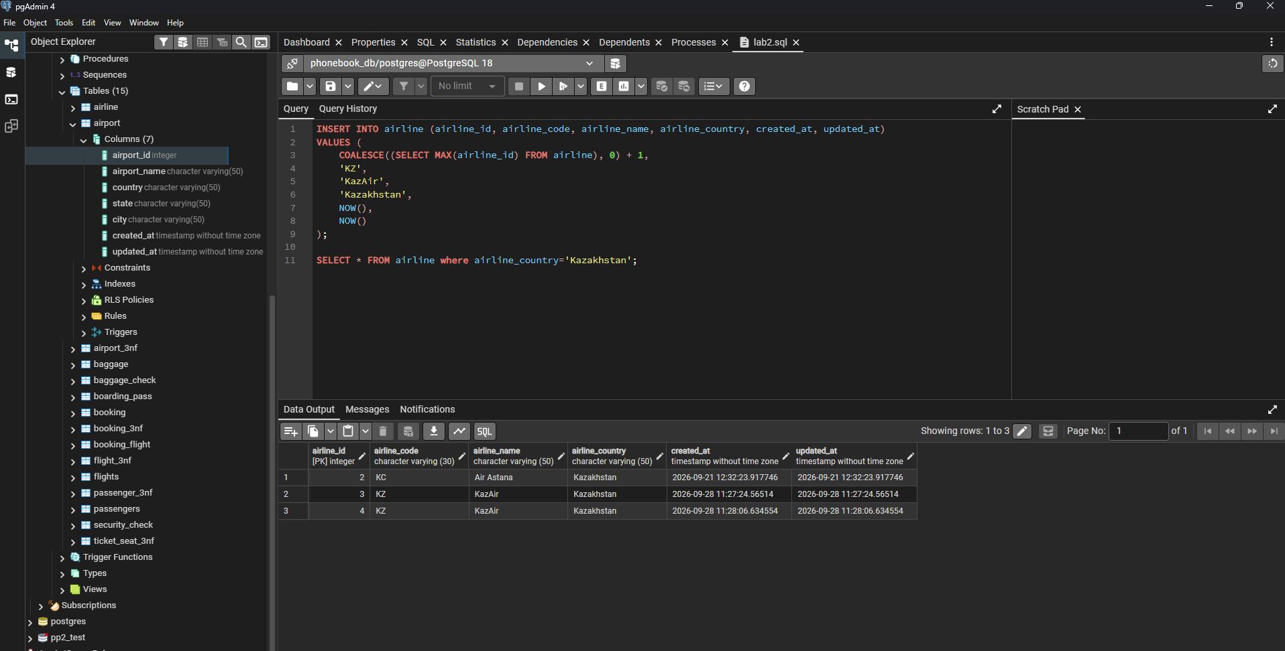

3. UPDATE airline SET airline_country = 'Turkey', updated_at = NOW() WHERE airline_name = 'KazAir';
SELECT * FROM airline where airline_country='Turkey';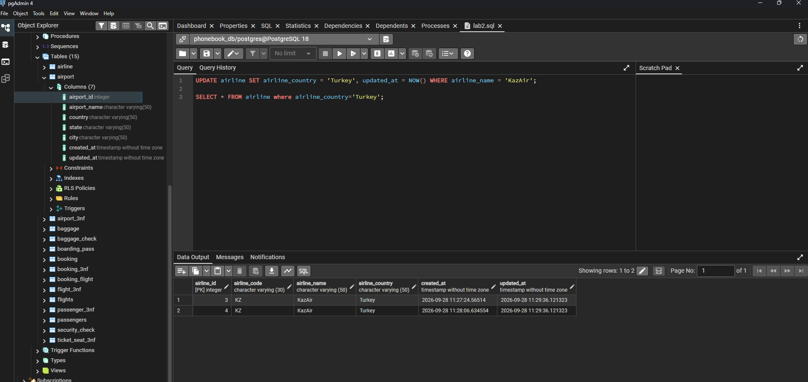

4. INSERT INTO airline (airline_id, airline_code, airline_name, airline_country, created_at, updated_at)
VALUES (COALESCE((SELECT MAX(airline_id) FROM airline), 0) + 1, 'AE', 'AirEasy', 'France', NOW(), NOW()),
(COALESCE((SELECT MAX(airline_id) FROM airline), 0) + 2, 'FH', 'FlyHigh', 'Brazil', NOW(), NOW()),
(COALESCE((SELECT MAX(airline_id) FROM airline), 0) + 3, 'FF', 'FlyFly', 'Poland', NOW(), NOW());

SELECT airline_country FROM airline;
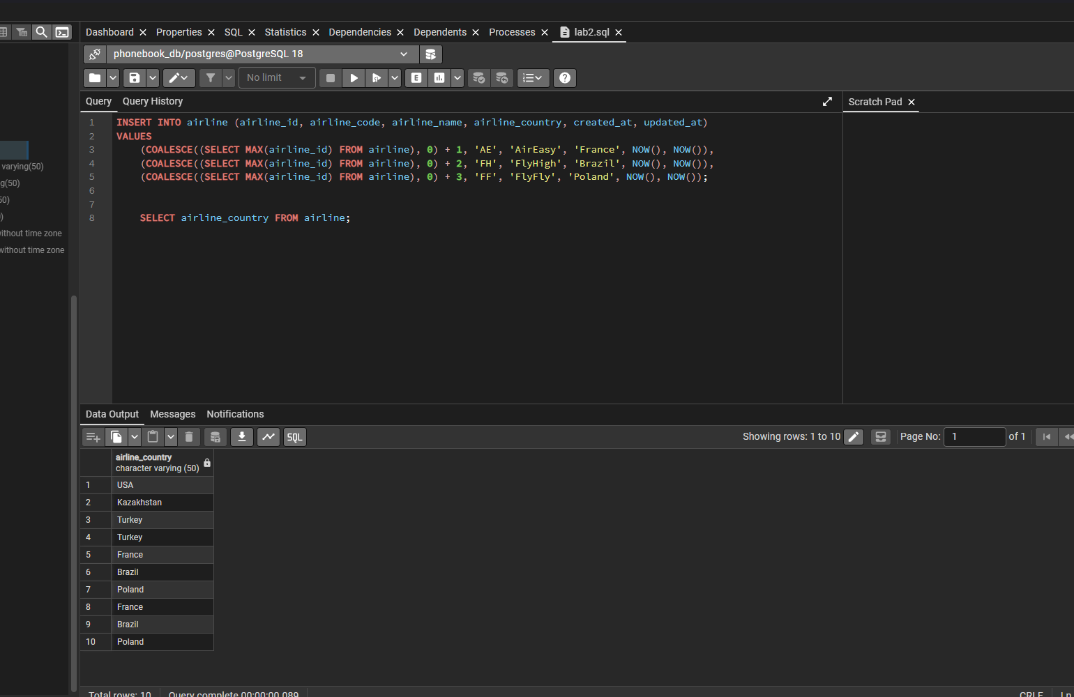

5. DELETE FROM flights
WHERE EXTRACT(YEAR FROM act_arrival_time) = 2024;
SELECT act_arrival_time FROM flights;

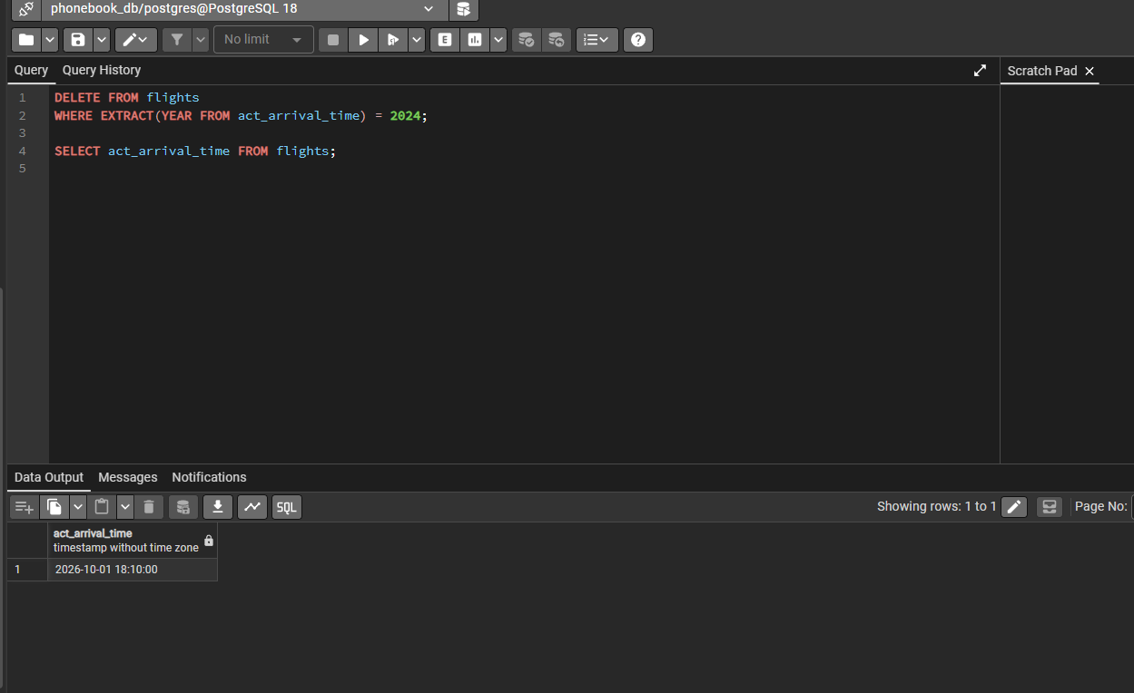

6. UPDATE booking SET ticket_price = ticket_price * 1.15;
SELECT ticket_price FROM booking;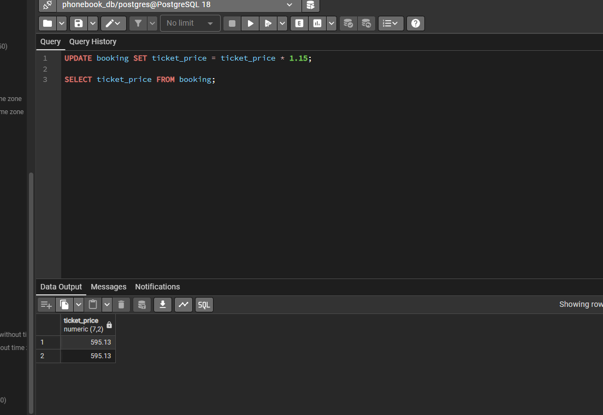

7. ALTER TABLE baggage_check DISABLE TRIGGER ALL;
ALTER TABLE baggage DISABLE TRIGGER ALL;
ALTER TABLE boarding_pass DISABLE TRIGGER ALL;
ALTER TABLE booking DISABLE TRIGGER ALL;

DELETE FROM booking WHERE ticket_price < 10000;

ALTER TABLE baggage_check ENABLE TRIGGER ALL;
ALTER TABLE baggage ENABLE TRIGGER ALL;
ALTER TABLE boarding_pass ENABLE TRIGGER ALL;
ALTER TABLE booking ENABLE TRIGGER ALL;
SELECT ticket_price FROM booking;
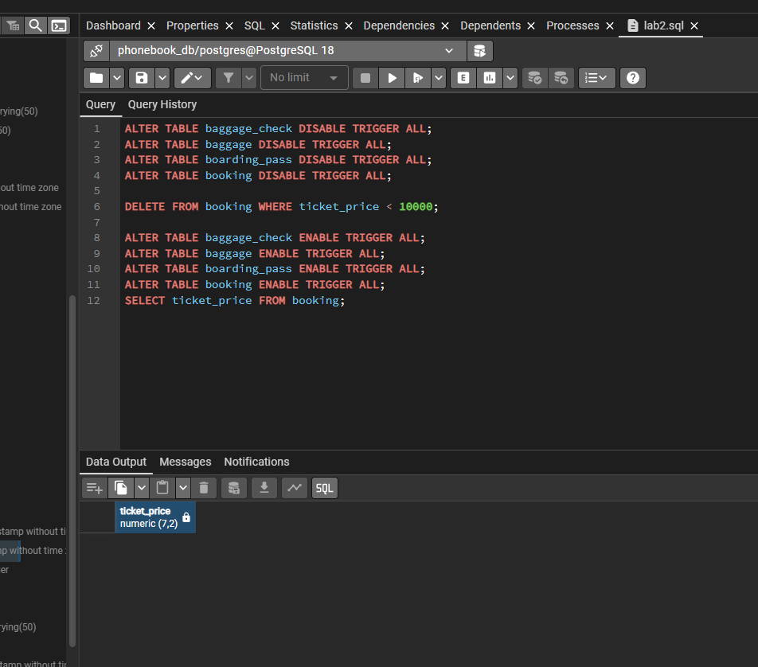

8. UPDATE airline SET airline_code = 'UNK' WHERE airline_code IS NULL;
SELECT * FROM airline WHERE airline_code='UNK';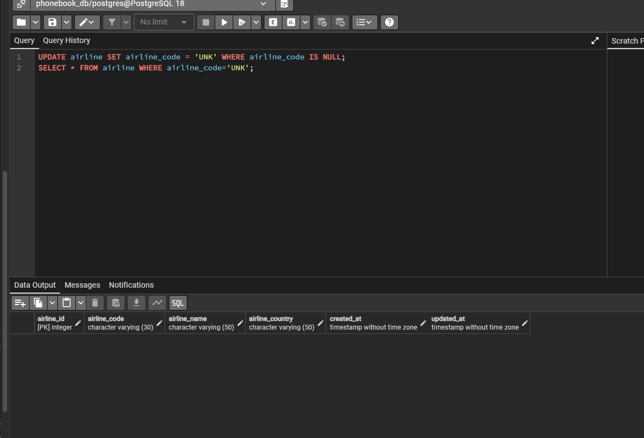
9. DELETE FROM baggage_check WHERE created_at < '2023-06-01' AND check_result = 'Not checked';

SELECT * FROM baggage_check WHERE created_at < '2023-06-01' AND check_result = 'Not checked';
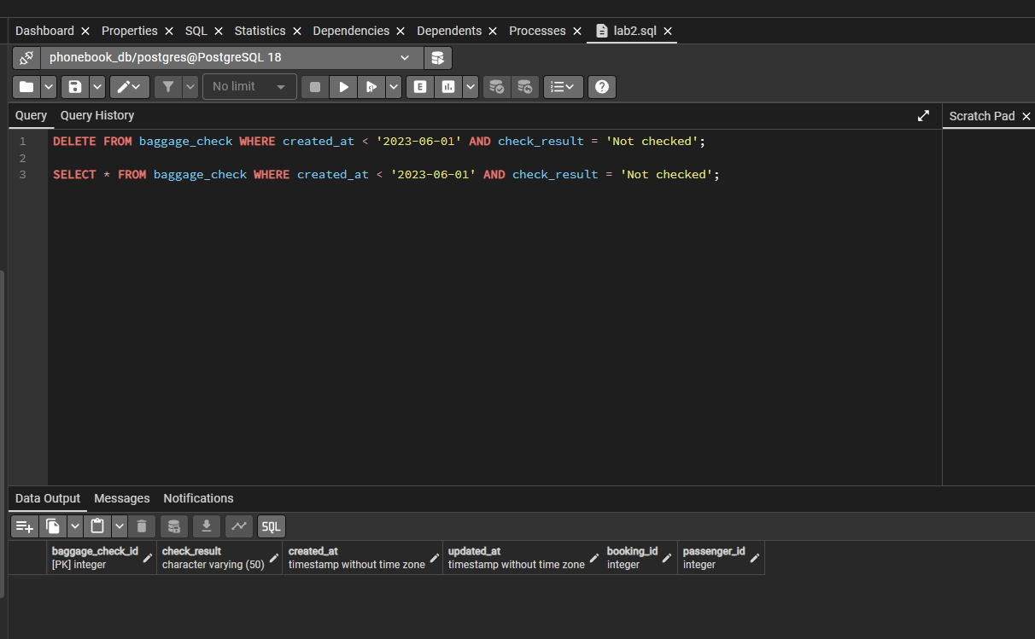
10. DELETE FROM airport WHERE state IS NULL AND city IN ('Mlawe', 'Kepuh');
SELECT * FROM airport WHERE city='Mlawe' AND city='Kepuh';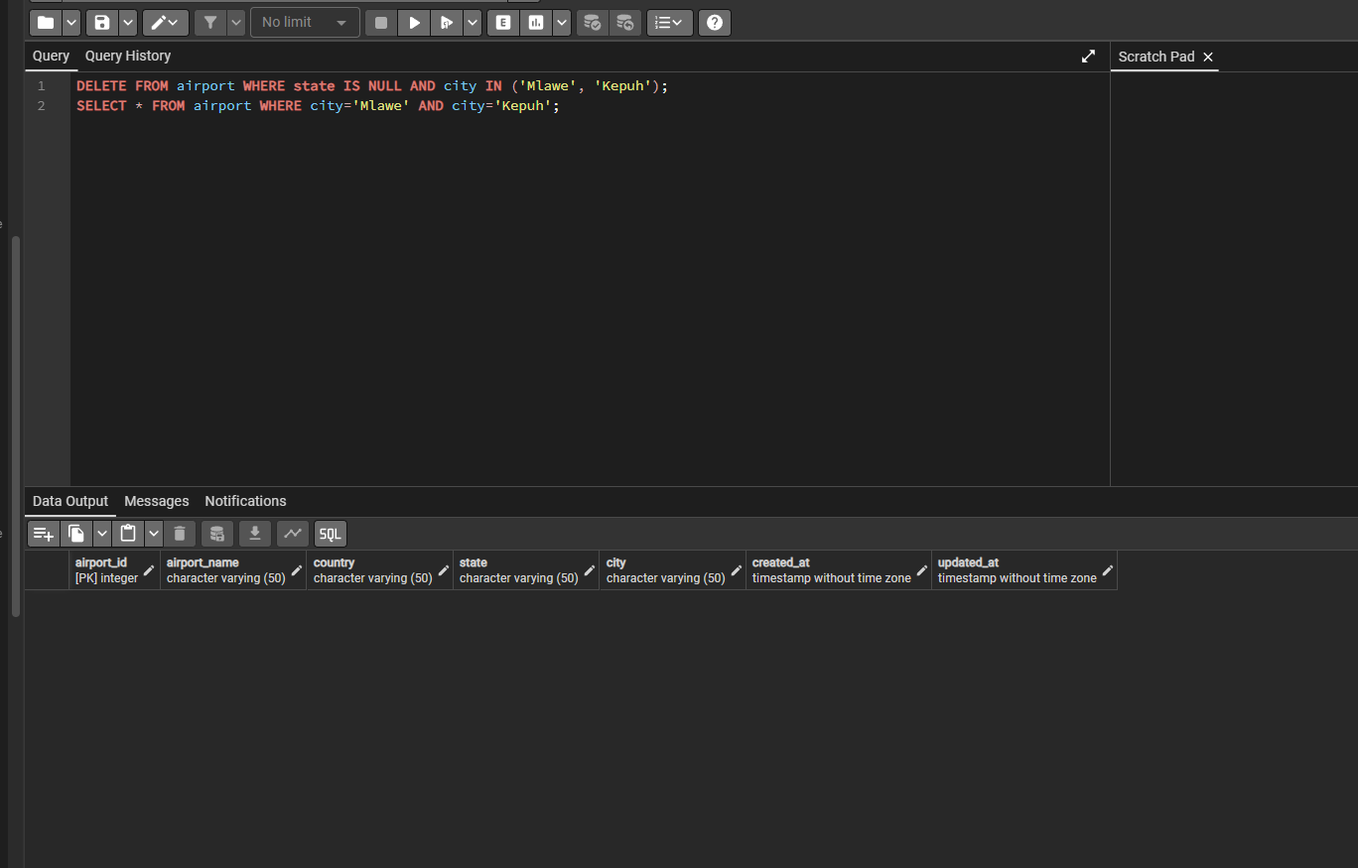

11. INSERT INTO booking (booking_id, flight_id, passenger_id, booking_platform, created_at, updated_at, status, ticket_price)
VALUES (
COALESCE((SELECT MAX(booking_id) FROM booking), 0) + 1,
(SELECT flight_id FROM flights LIMIT 1),
(SELECT passenger_id FROM passengers LIMIT 1),
'Web',
NOW(),
NOW(),
'Confirmed',
15000.00
)
ON CONFLICT (booking_id) DO NOTHING;
INSERT INTO baggage_check (
baggage_check_id,
check_result,
created_at,
updated_at,
booking_id,
passenger_id
)
VALUES (
COALESCE((SELECT MAX(baggage_check_id) FROM baggage_check), 0) + 1,
'Not checked',
NOW(),
NOW(),
(SELECT booking_id FROM booking ORDER BY booking_id DESC LIMIT 1),
(SELECT passenger_id FROM passengers ORDER BY passenger_id DESC LIMIT 1)
);

SELECT * FROM booking WHERE status='Not checked';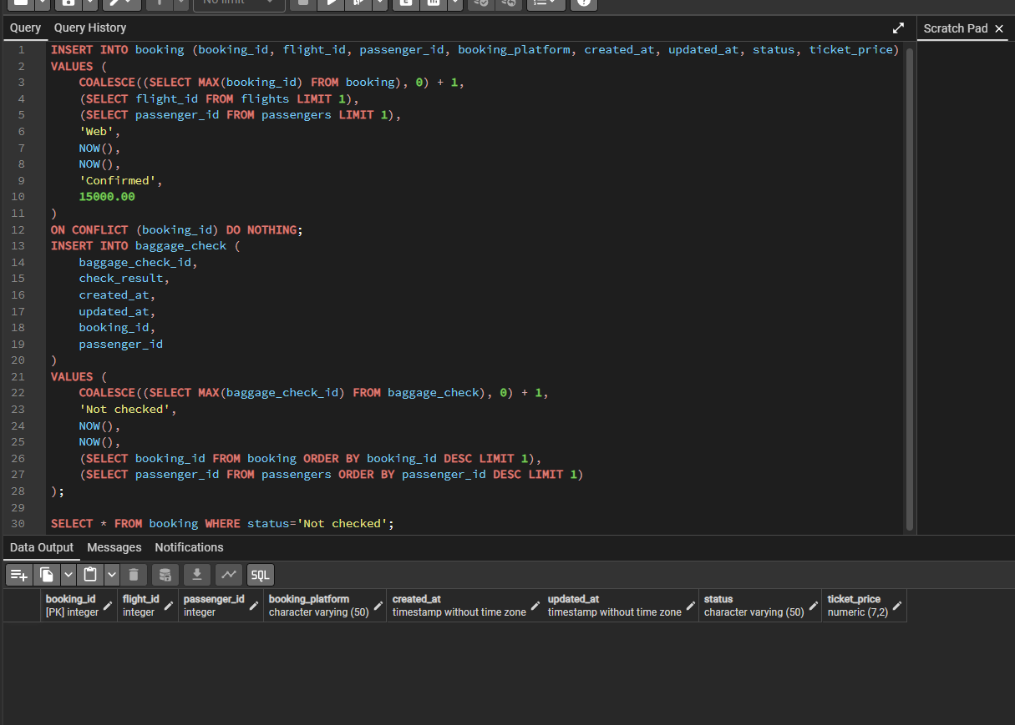

12. UPDATE airline SET airline_country = UPPER(airline_country);

SELECT airline_country FROM airline;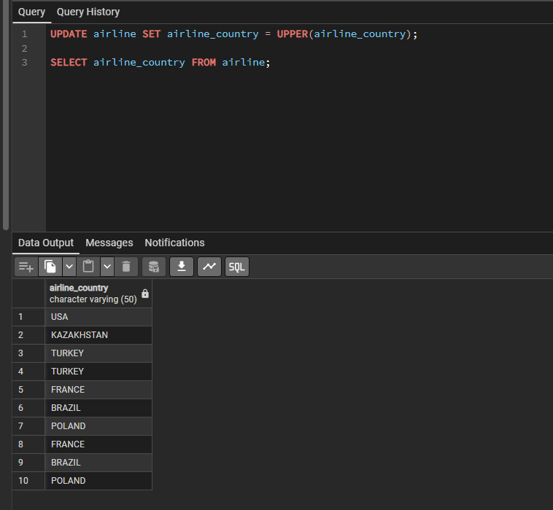

13. UPDATE airline
SET airline_name = 'Global Airways',
airline_country = 'United Kingdom',
updated_at = CURRENT_DATE WHERE airline_id = 5;

SELECT * FROM airline WHERE airline_id=5;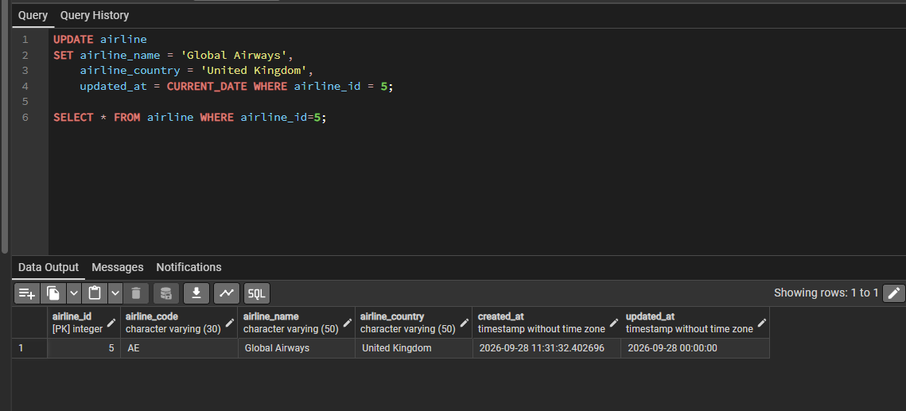

14. UPDATE airport
SET state = 'Capital District'
WHERE city IN ('Astana', 'London', 'Tokyo');

SELECT city FROM airport WHERE state='Capital District';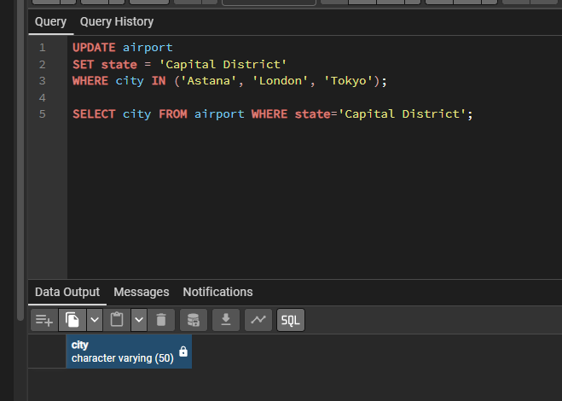

15. UPDATE baggage_check
SET check_result = 'Checked'
WHERE check_result = 'Not checked'
AND created_at >= '2024-03-01'
AND created_at < '2024-04-01';

SELECT * FROM baggage_check WHERE check_result='Checked' AND created_at >= '2024-03-01' AND created_at < '2024-04-01';